**Assignment**

**Introduction**

This project involves extracting data from an Excel sheet, storing it in Firebase Realtime Database, and developing an API using FastAPI to expose the data to a frontend application. The frontend will display the data retrieved from the API.

**Tech Stack**

* **Backend**: Python, FastAPI
* **Database**: Firebase Realtime Database
* **Frontend**: React.js

**Project Workflow**

1. **Data Ingestion**: Extract data from an Excel file.
2. **Storage**: Store extracted data into Firebase Realtime Database.
3. **API Development**: Develop a FastAPI endpoint to fetch stored data.
4. **Frontend Integration**: Display the retrieved data in a sample frontend application.

**Step 1: Setting Up Firebase Realtime Database**

1. Go to [Firebase Console](https://console.firebase.google.com/)
2. Create a new project and enable Firebase Realtime Database.
3. Set database rules to allow read/write access:

{

"rules": {

".read": true,

".write": true

}

}

1. Get the Firebase configuration JSON file and save it as firebase_config.json.

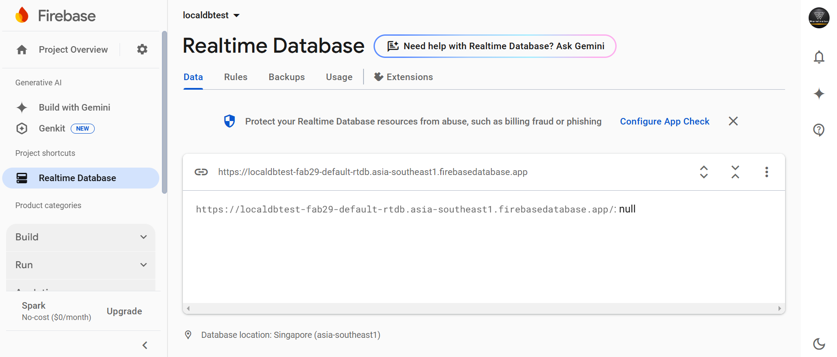

**Step 2: Backend Implementation**

**Install Dependencies**

pip install fastapi uvicorn pandas openpyxl pyrebase4

**Backend Code (FastAPI & Firebase Integration)**

**main.py**

**# import modules and library**

*# Initialize Firebase*

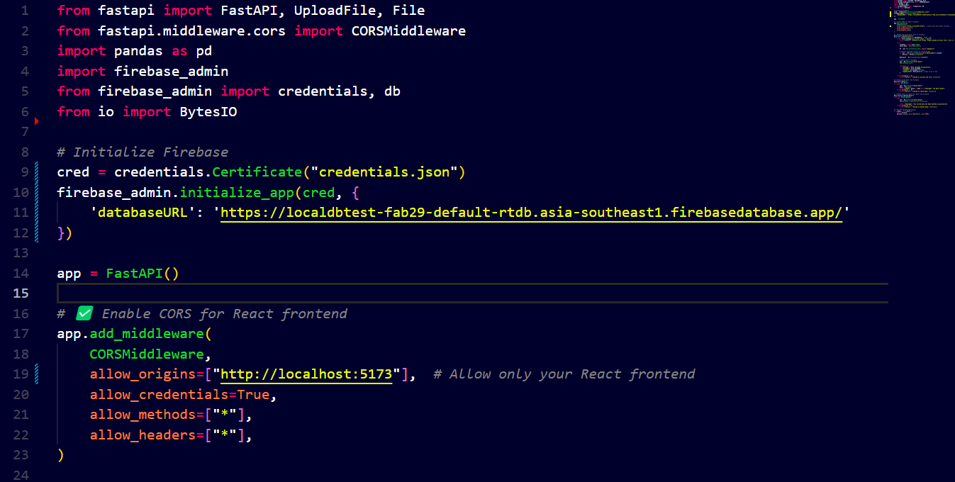

*# ✅ Upload and store Excel data in Firebase*

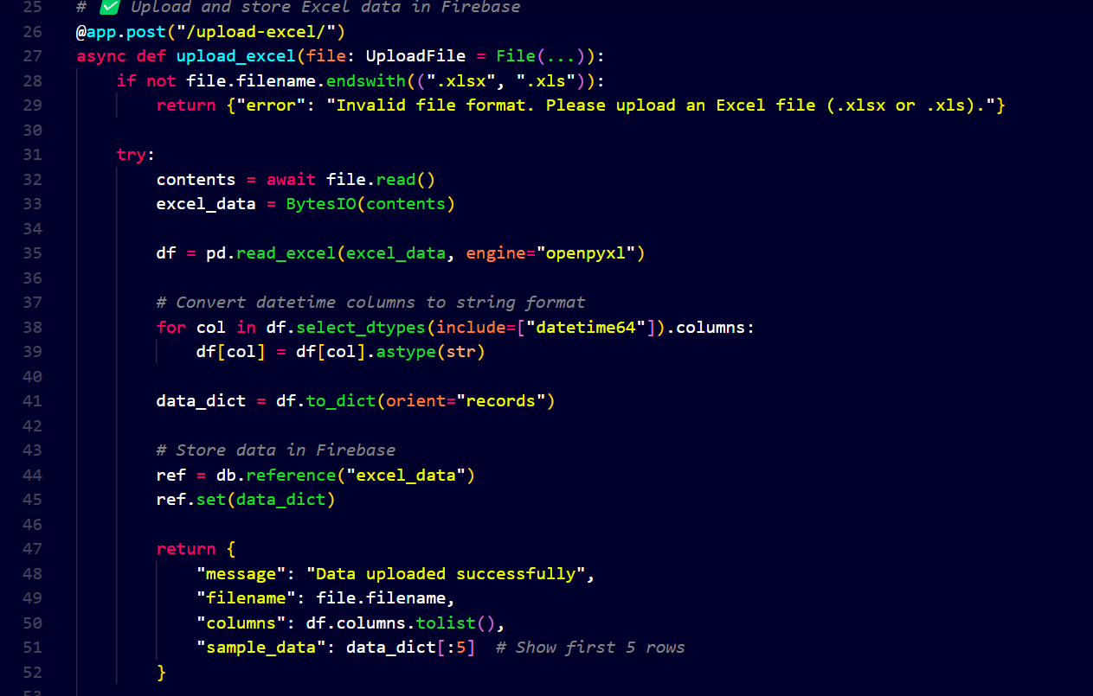

*# ✅ Fetch and delete stored data from Firebase*

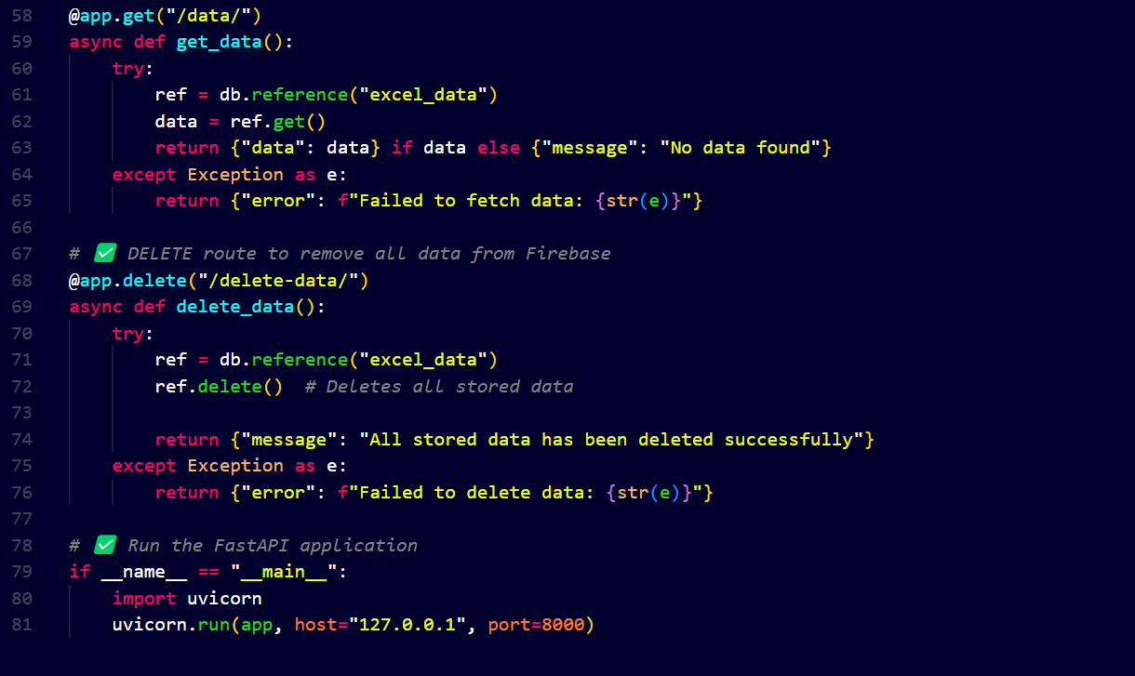

*# ✅ Run the FastAPI application*

if __name__ == "__main__":

    import uvicorn

    uvicorn.run(app, host="127.0.0.1", port=8000)

**Step 3: Running the Backend**

uvicorn main:app –reload

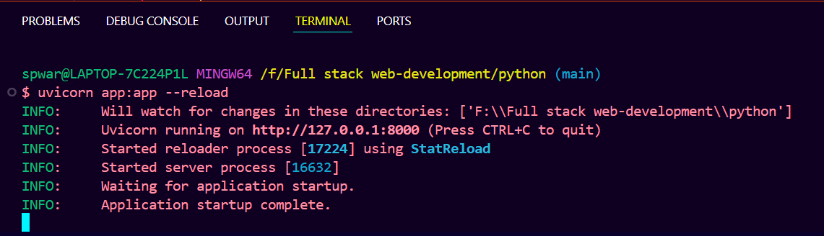

This will start the FastAPI server at http://127.0.0.1:8000/

**API Endpoints:**

* **POST /upload/**: Upload an Excel file and store data in Firebase.
* **GET /data/**: Retrieve stored data from Firebase.

**Step 4: Frontend Implementation**

Created a simple frontend to fetch and display data.

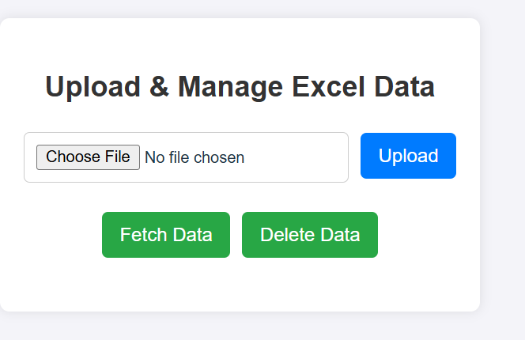

**Upload and fetch**

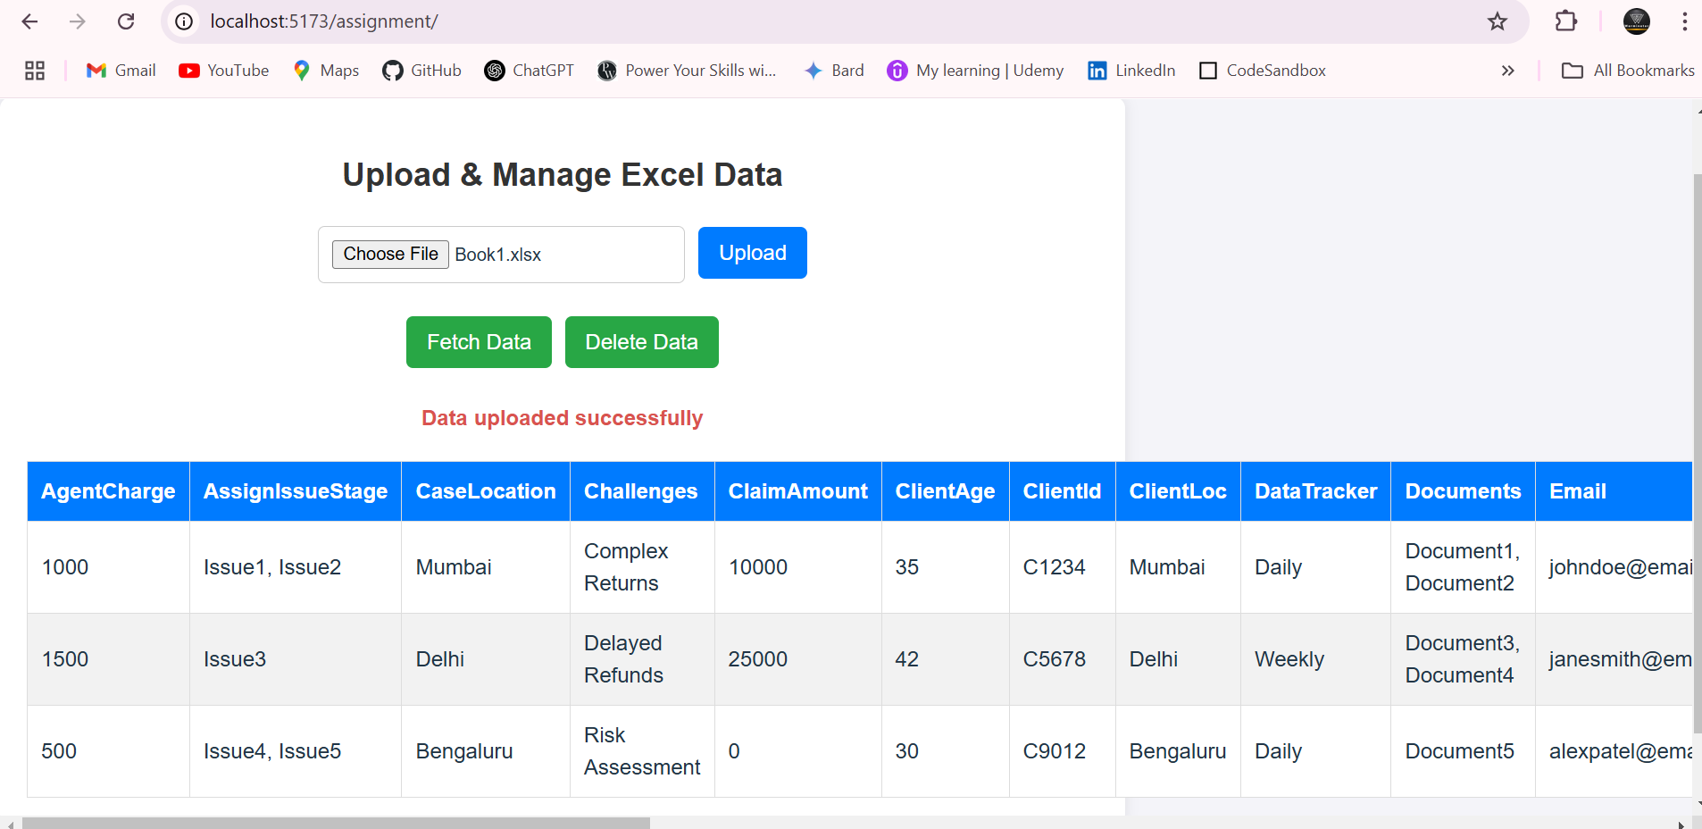

**Delete data**

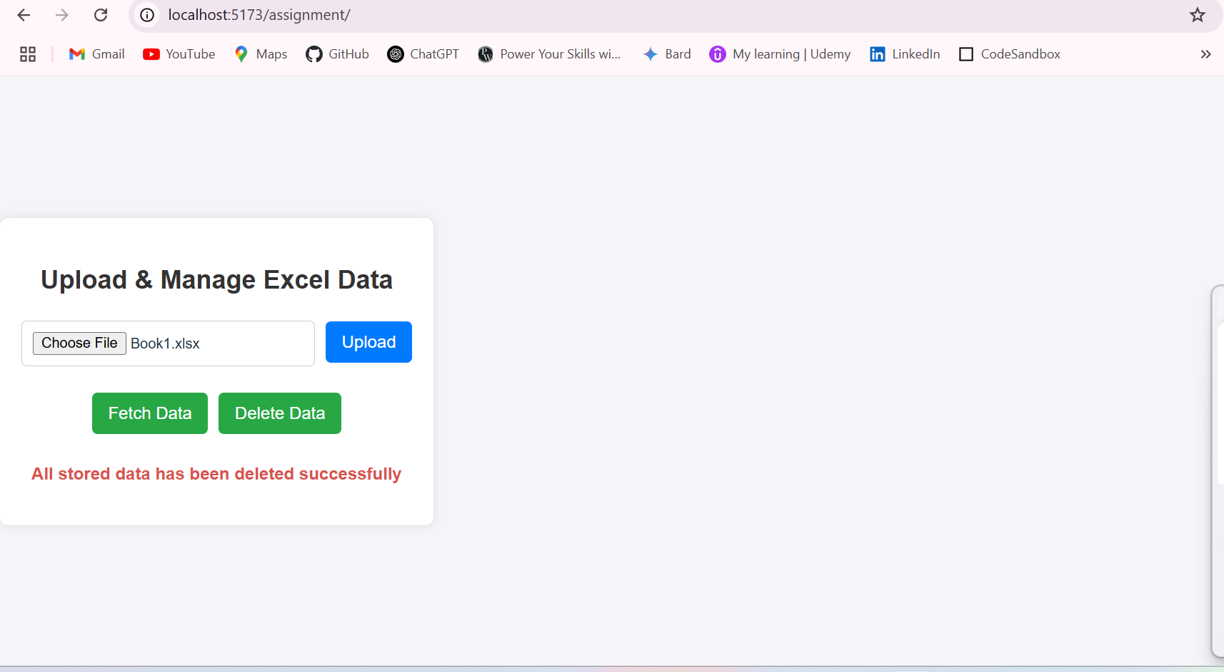

**Conclusion**

This project demonstrates a complete workflow from data extraction to API development and frontend visualization using FastAPI, Firebase, and React.